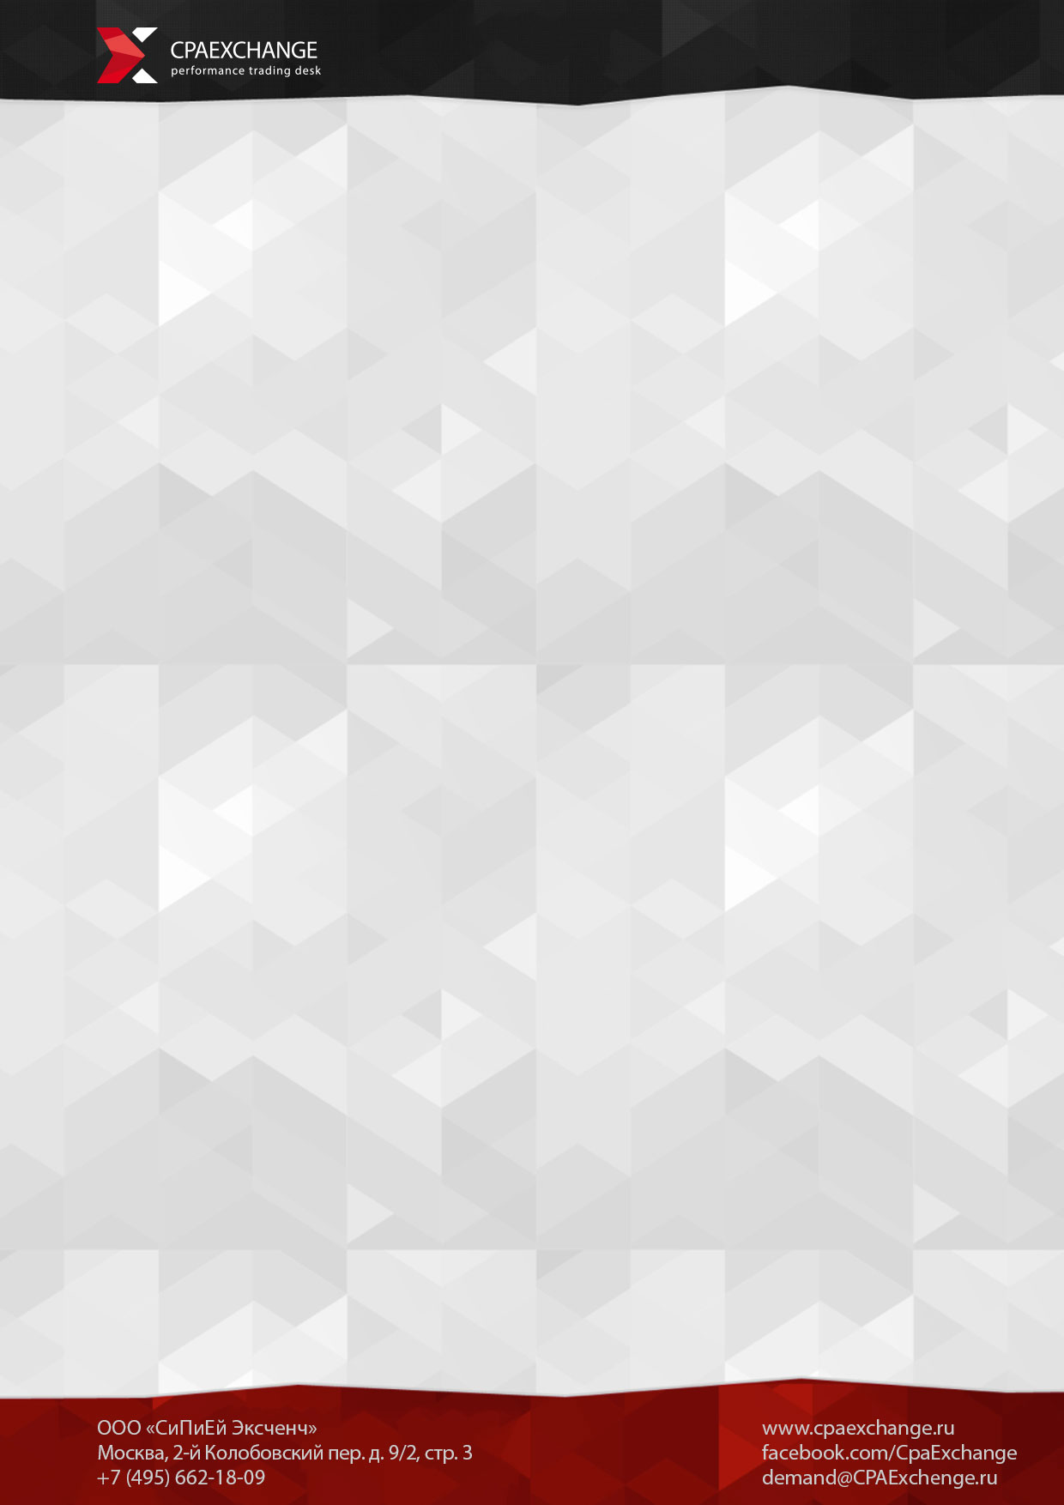
Client brief (Mobile)
Please send us e-mail with completed application form on demand@cpaexchange.ru

MAIN INFORMATION

Company's name?
Contact info?
(Surname, name, tel., e-mail, position)
Категория приложения? Базовый функционал?
Action type?
(Download of application, installing)
Target audience?
(gender, age, social info)
Geography?
Which OS your application use?
Previous version of application's stat (if it's not first): number of downloads
period of being in marketplace
conversion of loads per opens (app page)
traffik types
Application/landing link?
What the price per Lead do you prefer?
(without VAT tax)
What amount of Leads per Month do you prefer?
Period of the campaign?
When do you want to start?
What tracking system are you using?

CPAExchange thinks:
- Traffic, gained from prohibited sites by Russian laws, is invalid.
- Traffic, gained by hacks, exploites, etc. - prohibited
You can choose, what traffic you don't work with:
- Yandex.Direct
- Google.Adwords
- SocialMedia (choose one from offer/context/public adverts)
- Begun
- Mobile adverts
- RTB-channel
- Incentivized
- Redirect
- Legal e-mail adverts (only official, no spam)
- Subscribe e-mails (only official, large base)
- Porn traffic
- Game traffic
- Doorway traffic
- Cashback

Its important if you use many targetings the price will be growing up.

